Google Search Console

Create a Google Search Console account

Select the url prefix

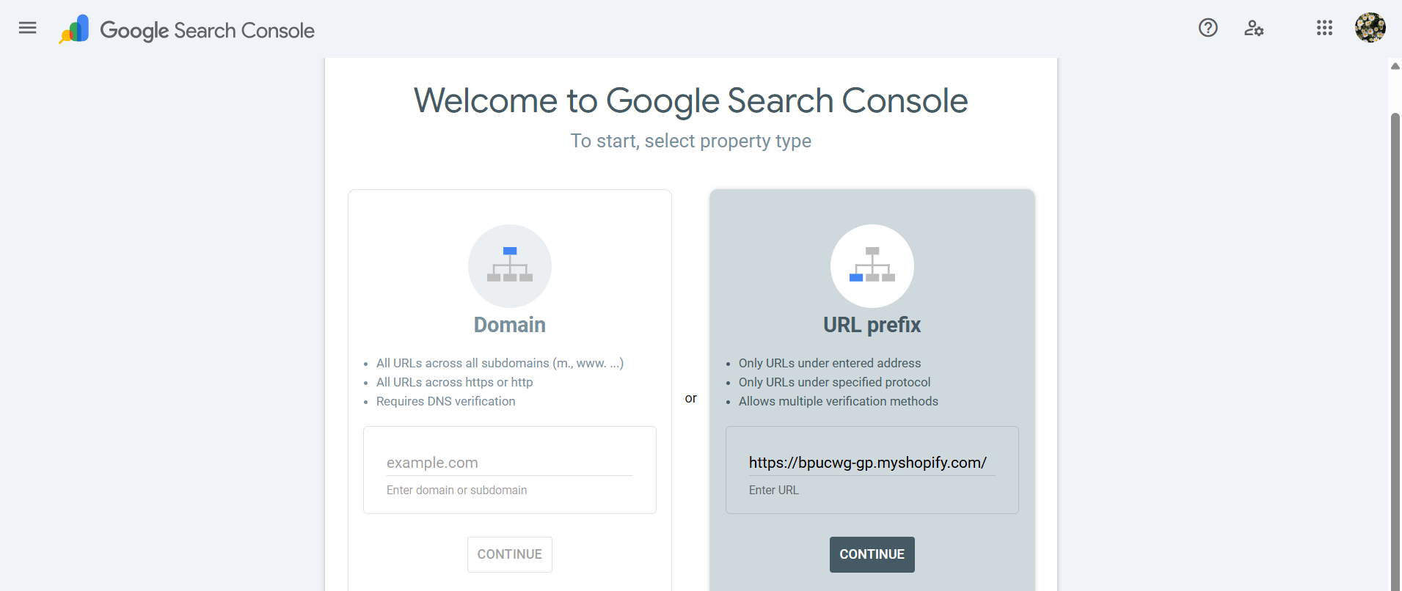

Then I am using the html tag to verify my account

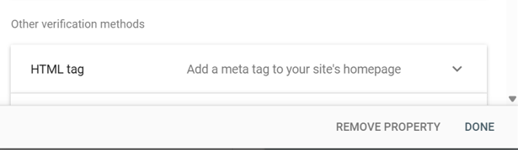

Then in shopify Path: shopify section module>online store> theme> select the meatball symbol near the customize button>edit code

Then add the theme.liquid section add the copied HTML tag inside the head tag and save.

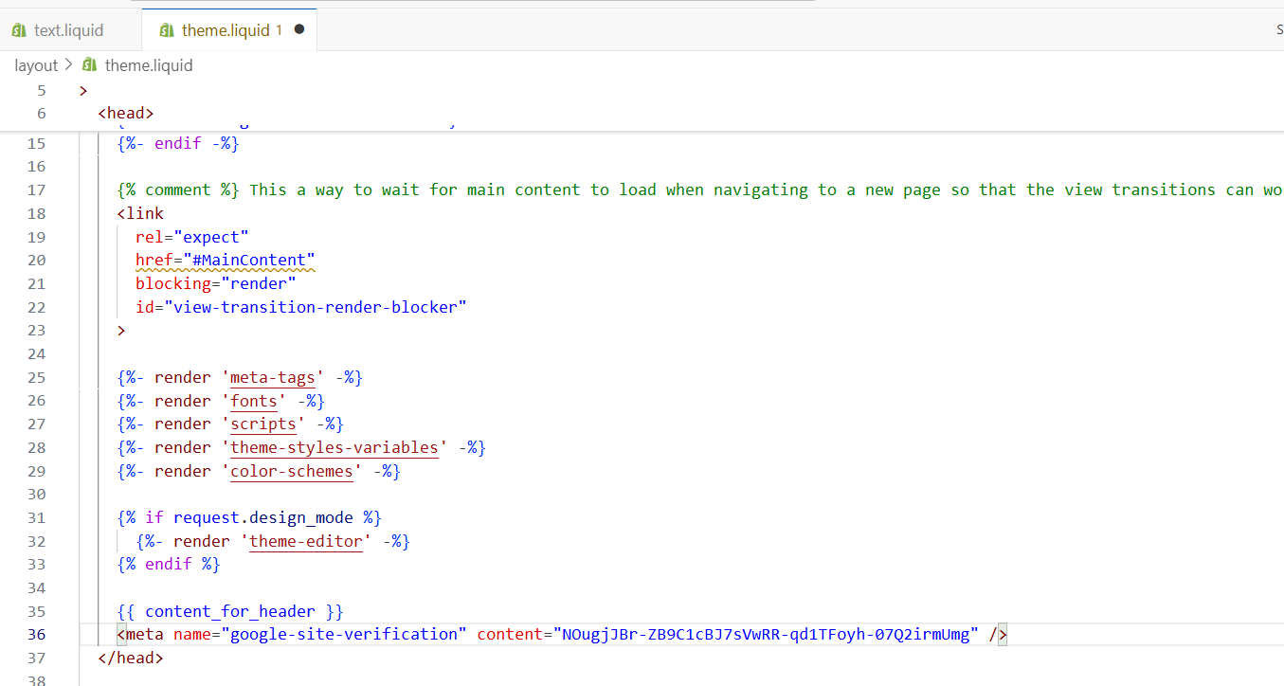

Then check for verify via method HTML tag

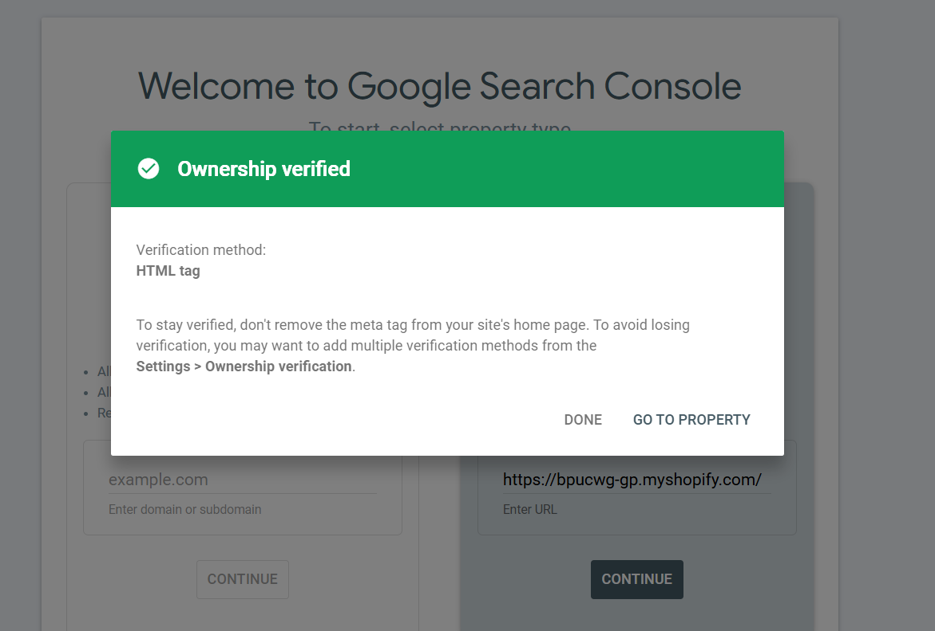

Google search console opened

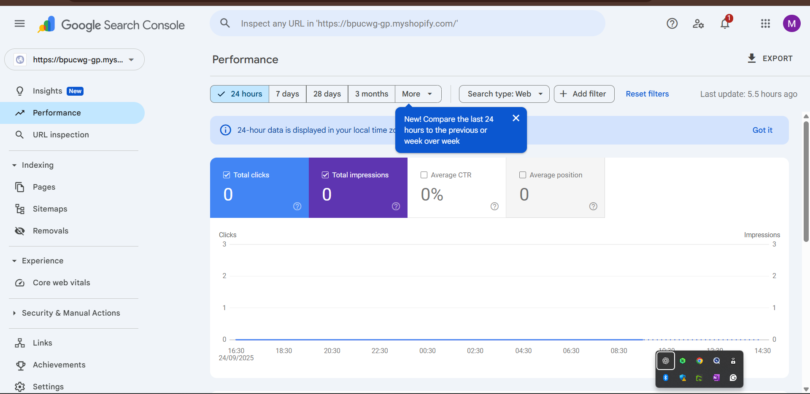

We can monitor, and maintain our site presence in search engine.

If we our website page has sitemap not update in a recent time then we can check and update it we can declare a page is index or noindex page, remove unwanted files like images, videos, and we can minimize the size of the webpage so that can help to increase the page speed. We can check the impressions and click through rate.

We can create a query (user types(word,phrase) in a google search) related keywords in Google search console.

LINK WITH GOOGLE ANALYTICS:

Path: google analytics>admin>property setting>product links>search console links

Link the property
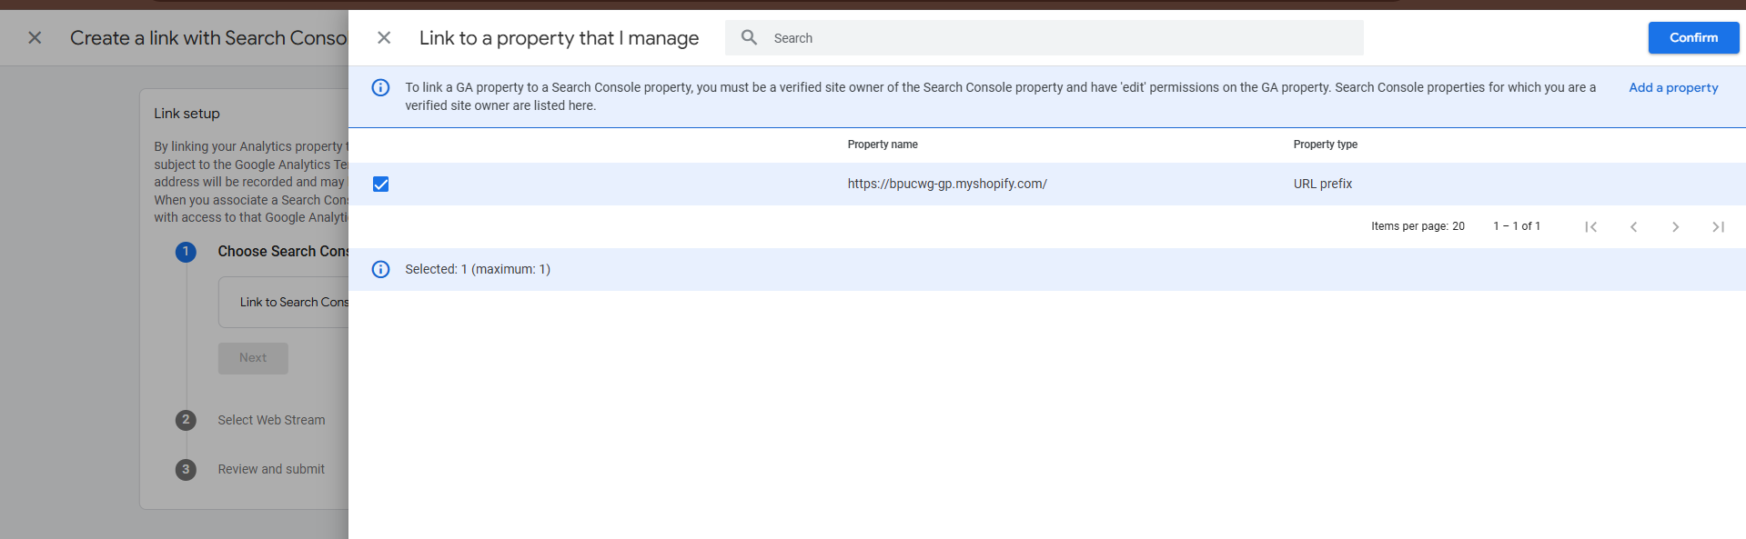

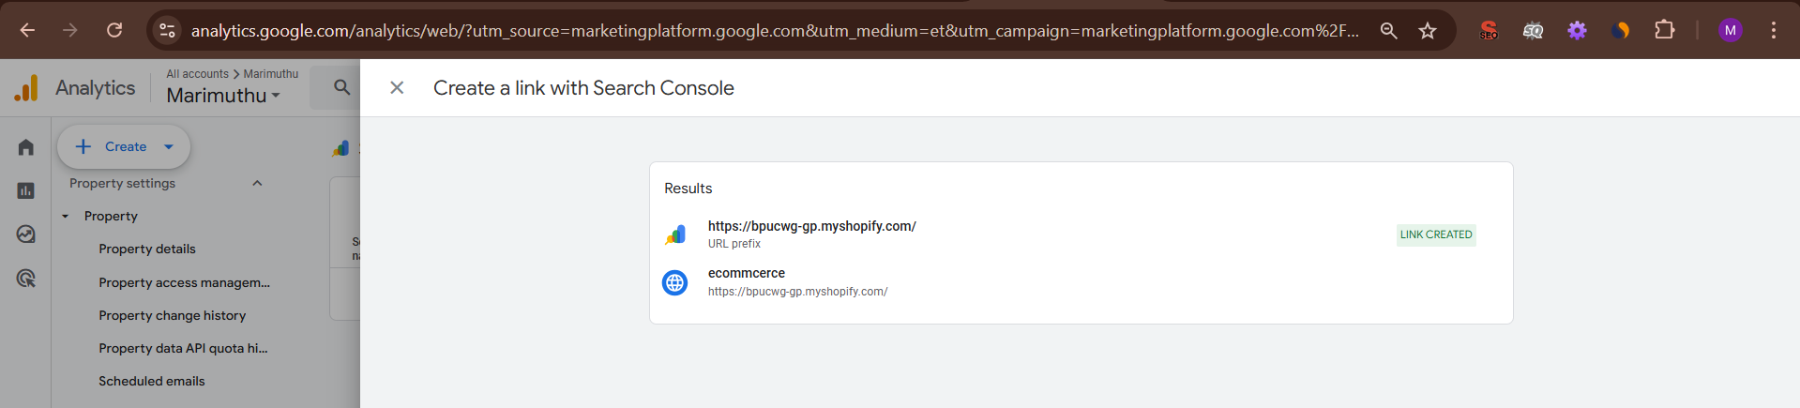

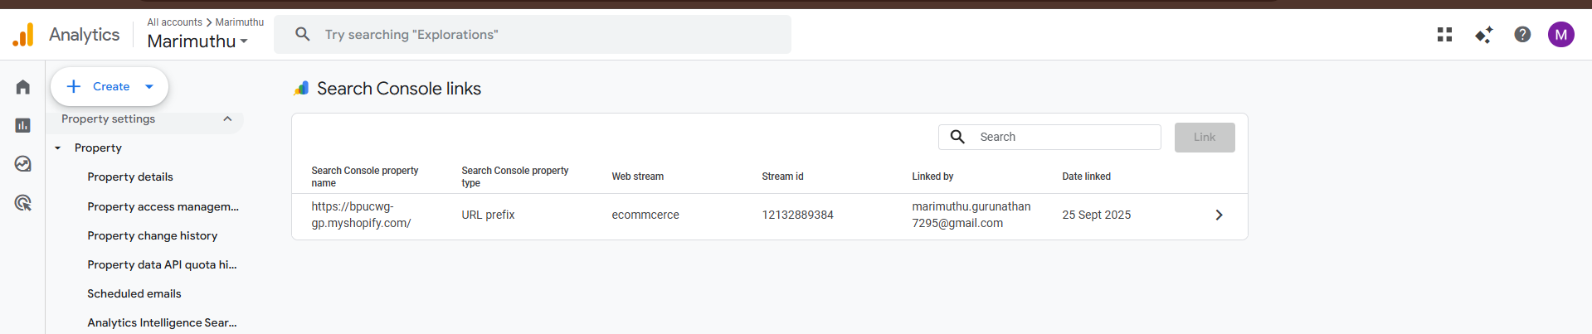

Google Search Console is linked with Google Analytics.

